000님 session 00
Pregnancy (강사용)
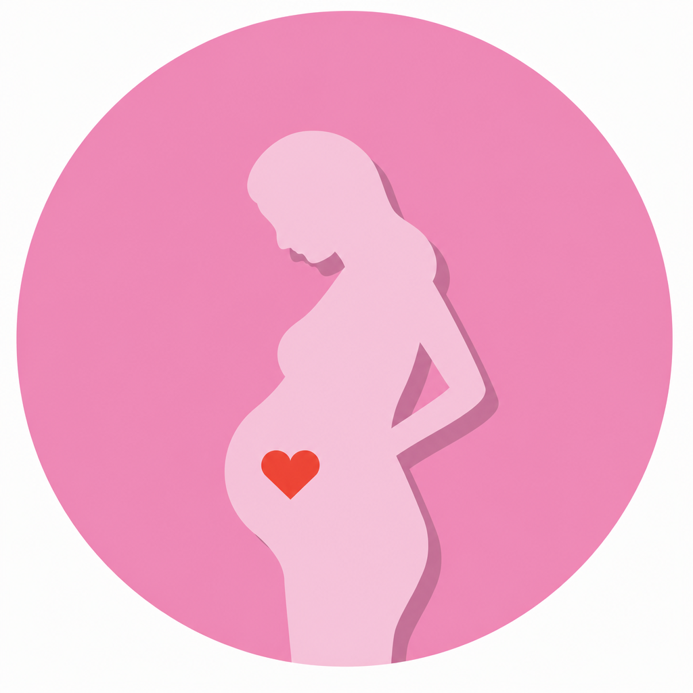
Warm-Up / Vocabulary Preview / Reading / Comprehension

Warm-Up
다음 질문에 대해 이야기해 보세요. 힌트를 참고해도 좋아요.
Q What symptoms are associated with early pregnancy?
Hint: morning sickness, fatigue, a missed period
Q What do women do if they suspect they are pregnant?
Hint: take a home pregnancy test, book a doctor's appointment
Q In your region, what options do women have for delivering their babies?
Hint: a general hospital, a women's hospital, natural birth vs. C-section
Q Are there any special traditions related to pregnancy in Korea?
Hint: taemong (a conception dream), eating seaweed soup after giving birth
Q Are baby showers or gender reveal parties common in Korea? Have you ever been to one?
Hint: who hosts it, gifts, games, cutting the cake
Q What are you most looking forward to about becoming a mom?
Hint: meeting the baby, choosing a name, buying baby clothes

Vocabulary Preview
임신·출산과 관련해 병원과 일상에서 실제로 자주 쓰는 단어들입니다. 이미 아는 단어에 체크해 보세요.
Word | Meaning | Example
home pregnancy test | a test kit you use at home to check if you are pregnant  임신 테스트기 | I took a home pregnancy test, and it was positive!
morning sickness | feeling sick or nauseous in early pregnancy  입덧 | I've been suffering from morning sickness these days.
due date | the day the baby is expected to be born  출산 예정일 | My due date is in early December.
trimester /traɪˈmestər/ | one of the three stages of pregnancy  임신 3분기 중 하나 (1분기 = 임신 초기) | I'm in my second trimester now.
ob-gyn /ˌoʊ.biː.dʒiː.waɪˈen/ | a doctor for pregnancy and childbirth  산부인과 전문의 | I have an appointment with my ob-gyn tomorrow.
prenatal checkup | a regular medical visit during pregnancy  산전 검진 | I go in for a prenatal checkup every four weeks.
ultrasound | a scan that shows the baby inside the womb  초음파 (검사) | We saw the baby moving during the ultrasound.
heartbeat | the sound of the heart beating  심장 박동 | We heard the baby's heartbeat for the first time!
find out the baby's sex | learn if the baby is a boy or a girl  아기 성별을 알게 되다 | We're going to find out the baby's sex next week.
gestational diabetes /dʒeˌsteɪʃənl ˌdaɪəˈbiːtiːz/ | high blood sugar during pregnancy  임신성 당뇨 | I got tested for gestational diabetes last week.
contractions /kənˈtrækʃənz/ | strong, repeated pains before the baby is born  진통 | My contractions are about ten minutes apart.
my water broke | the fluid around the baby came out  양수가 터졌어요 | My water just broke — we need to go to the hospital!
epidural /ˌepɪˈdʊrəl/ | an injection that blocks pain during labor  무통 주사 | I'm planning to get an epidural.
C-section /ˈsiː ˌsekʃən/ | surgery to deliver a baby  제왕절개 | My first baby was born by C-section.
labor and delivery /ˈleɪbər/ | the process of giving birth  분만과 출산 | I was in labor for ten hours.
newborn | a baby that was just born  신생아 | Newborns sleep most of the day.
NICU /ˈnɪkjuː/ | neonatal intensive care unit — for newborns who need special care  신생아 집중치료실 | The baby stayed in the NICU for a few days.
breastfeed / formula | feed the baby with mother's milk / powdered baby milk  모유 수유하다 / 분유 | I haven't decided whether to breastfeed or use formula.
postpartum /ˌpoʊstˈpɑːrtəm/ | related to the time after giving birth  산후의 | Postpartum care is really important in Korea.
announce the pregnancy | tell people that you are pregnant  임신 사실을 알리다 | We announced the pregnancy to our parents first.
the 12-week mark | the point when the pregnancy becomes more stable  임신 12주차 (안정기 시작) | We waited until the 12-week mark to tell our friends.
gender reveal /rɪˈviːl/ | an event to share whether the baby is a boy or a girl  성별 공개 (이벤트) | We cut a cake at our gender reveal party.
postpartum care center (= joriwon) | a place where moms rest and recover after giving birth  산후조리원 | I've already booked a postpartum care center.
miscarriage /ˈmɪsˌkærɪdʒ/ | losing a baby before it is able to be born  유산 | The risk of miscarriage goes down after the first trimester.

Reading 1 — Types of Appointments
소리 내어 읽어 보세요.

1 When a woman thinks she might be pregnant, she can take a home pregnancy test. Early signs include a missed period, morning sickness, and fatigue. If the test is positive, the next step is to book an appointment with an ob-gyn and start regular prenatal checkups.

2 In the first trimester, the doctor does an ultrasound to check the baby's heartbeat and confirm the due date. In the second trimester, most women are tested for gestational diabetes — you drink a very sweet drink and then have a blood test. This is also when many parents find out the baby's sex.

3 In the third trimester, checkups become more frequent. The doctor checks the baby's growth, movement, and position. As the due date gets closer, the doctor and the parents also talk about the delivery — for example, whether to get an epidural, and what to do when labor starts.

4 When labor starts, the mother feels contractions, and sometimes her water breaks. When the contractions get closer together, it's time to head to the hospital. If there are complications, the baby may be delivered by C-section. After the birth, the newborn usually stays in the room with the mom, and if the baby needs extra care, the NICU team is there to help.

Reading 2 — Pregnancy & Childbirth Culture in Korea
한국의 임신·출산 문화를 영어로 설명해 보는 지문입니다. 소리 내어 읽어 보세요.

1 In Korea, many couples keep the news to themselves until the 12-week mark. The first trimester is not considered a “safe” stage yet, so moms-to-be usually announce the pregnancy to friends and coworkers only after 12 weeks.

2 These days, gender reveal events are becoming popular. For example, one partner finds out the baby's sex first and surprises the other — by cutting a cake that is pink or blue inside, or by opening a box full of balloons. It has become a fun way to share the news.

3 The biggest difference from other countries is postpartum care. After giving birth, most Korean moms stay at a postpartum care center, called a joriwon, for about two weeks. It is not a hospital — it is a place where moms rest and recover while trained staff take care of the newborns. Many foreigners find this culture unique to Korea.

Comprehension
지문 내용을 바탕으로 답해 보세요.
Q What are two early signs of pregnancy mentioned in the reading?
Q What happens at the first trimester ultrasound?
Q How is the test for gestational diabetes done?
Q What does the doctor check in the third trimester?
Q What are two signs that labor has started?
Q Why do many Korean couples wait until the 12-week mark to announce a pregnancy?
Q What is a joriwon, and what happens there?

Answer Key — 모범답안
Warm-Up
Q What symptoms are associated with early pregnancy?
A Common early symptoms include a missed period, morning sickness, and fatigue. Some women also feel tender breasts or sudden food cravings. In my case, I felt unusually tired before I even took the test.
흔한 초기 증상으로는 생리 중단, 입덧, 피로감이 있어요. 가슴이 민감해지거나 갑자기 특정 음식이 당기기도 해요. 저는 테스트해 보기 전부터 유난히 피곤했어요.

Q What do women do if they suspect they are pregnant?
A Most women take a home pregnancy test first. If it's positive, they book an appointment with an ob-gyn to confirm the pregnancy with an ultrasound and start prenatal checkups.
대부분 먼저 임신 테스트기로 확인해요. 양성이 나오면 산부인과에 예약해서 초음파로 임신을 확인하고 산전 검진을 시작해요.

Q In your region, what options do women have for delivering their babies?
A In Korea, most women give birth at a women's hospital or a general hospital. After the delivery, many moms stay at a postpartum care center called a joriwon for a week or two, which is quite unique to Korea.
한국에서는 대부분 여성병원이나 종합병원에서 출산해요. 출산 후에는 많은 엄마들이 조리원이라는 산후조리원에서 1~2주 지내는데, 이건 한국만의 독특한 문화예요.

Q Are there any special traditions related to pregnancy in Korea?
A Yes, we have taemong — a special dream that hints you are pregnant, often about animals or fruit. Also, after giving birth, Korean moms traditionally eat seaweed soup every day to recover.
네, 태몽이 있어요 — 임신을 암시하는 특별한 꿈인데 주로 동물이나 과일이 나와요. 또 출산 후에는 회복을 위해 매일 미역국을 먹는 전통이 있어요.

Q Are baby showers or gender reveal parties common in Korea? Have you ever been to one?
A They're becoming more common, especially baby showers among close friends, but they're still not as big as in the U.S. I've been to one — we played games and gave baby clothes as gifts.
점점 흔해지고 있어요. 특히 친한 친구들끼리 하는 베이비샤워요. 그래도 아직 미국만큼 크진 않아요. 저도 한 번 가봤는데, 게임도 하고 아기 옷을 선물했어요.

Q What are you most looking forward to about becoming a mom?
A Honestly, I'm most looking forward to finally meeting my baby. I also can't wait to choose a name and decorate the nursery, even though I know the sleepless nights are coming!
솔직히 아기를 드디어 만나는 게 가장 기대돼요. 이름 짓고 아기방 꾸미는 것도 너무 기대되고요. 잠 못 자는 밤들이 오겠지만요!

Comprehension
Q What are two early signs of pregnancy mentioned in the reading?
A A missed period, morning sickness, and fatigue. (Any two.)
생리 중단, 입덧, 피로감 (이 중 2가지)
Q What happens at the first trimester ultrasound?
A The doctor checks the baby's heartbeat and confirms the due date.
아기 심장박동을 확인하고 출산 예정일을 확정해요.
Q How is the test for gestational diabetes done?
A You drink a very sweet drink and then have a blood test.
아주 단 음료를 마신 뒤 혈액 검사를 해요.
Q What does the doctor check in the third trimester?
A The baby's growth, movement, and position.
아기의 성장, 움직임, 위치를 확인해요.
Q What are two signs that labor has started?
A The mother feels contractions, and sometimes her water breaks.
진통이 오고, 양수가 터지기도 해요.
Q Why do many Korean couples wait until the 12-week mark to announce a pregnancy?
A Because the first trimester is not considered a safe stage yet.
첫 3개월(1분기)은 아직 안정기가 아니라고 여겨지기 때문이에요.
Q What is a joriwon, and what happens there?
A It is a postpartum care center where moms rest and recover for about two weeks while trained staff take care of the newborns.
산후조리원이에요. 엄마가 약 2주간 쉬며 회복하고, 전문 인력이 신생아를 돌봐줘요.

